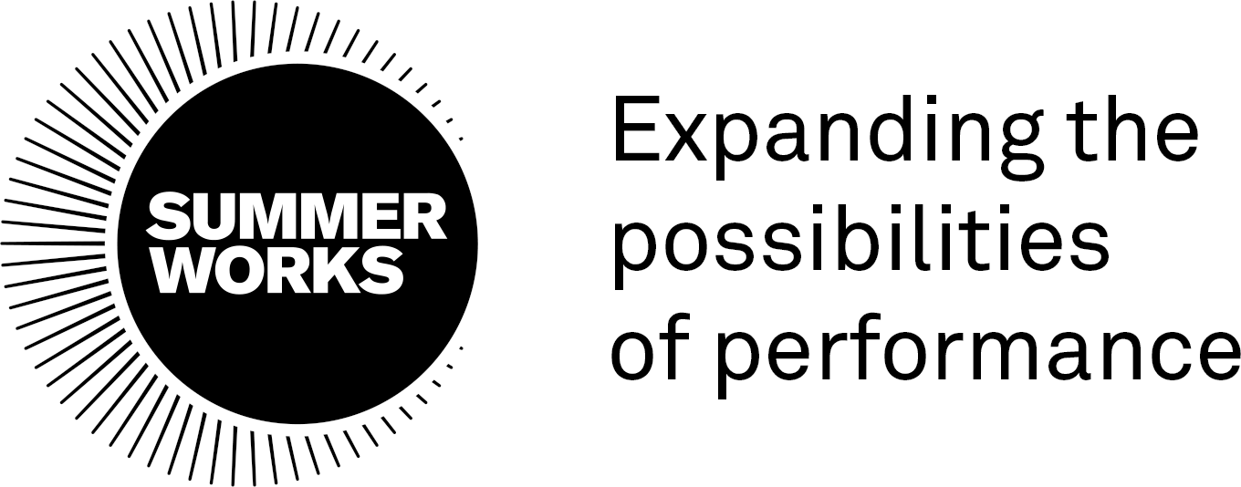

JOB POSTING: Production Manager - SummerWorks
____________________________________________________________

Title: Production Manager

Hours: May 27 - Aug 31, 2024
A mix of full- and part-time hours

Fee: $9,000 (+ HST, as applicable)

Engagement conditions: Independent Contractor

SummerWorks expands the possibilities of performance. We are a leader, collaborator, and community builder at the forefront of contemporary performance – asking crucial questions; nurturing artistic innovation; and presenting new works that reflect the complexity and diversity of our society. Anchored by our annual SummerWorks Performance Festival in August, SummerWorks offers creation, presentation, and learning opportunities for artists and audiences. www.summerworks.ca.

The SummerWorks team works a combination of remote and in-person hours.

SummerWorks is committed to equality and diversity, both through our program of activities and as an employer. Our practices and procedures aim to reflect the varied needs, expectations and cultures of all members of our community. We make every effort to ensure that no member of the community receives less favorable treatment in our recruitment process or when accessing our services on the grounds of gender identity, disability, race, religion or belief, age or sexual orientation.

We warmly encourage applications from equity-deserving groups, including those who identify as Indigenous, Black, People of Colour, Transgender, Nonbinary, Queer, Disabled, Mad, and intersections of those identities.

SummerWorks will work proactively through all stages of recruitment to create a barrier-free hiring process and work environment, and will strive to provide accommodations when/where possible. For specific questions related to accessibility at SummerWorks, please visit https://summerworks.ca/accessibility/ or email info@summerworks.ca.

Production Manager: Description & Duties

The Production Manager is an essential role within our Festival team. They will work with the Festival Producer and Artistic and Managing Directors to ensure the smooth operation of the production department for the 2024 SummerWorks Performance Festival (August 1-11) and maintain oversight of all production and technical requirements for the Festival, including staffing, scheduling, and costing.
Reports to: Artistic Director & Managing Director
Direct reports: Assistant Production Manager, Production Assistants, Festival Lighting Designers, and Technicians
____________________________________________________________

Production Manager: Responsibilities
Planning
- Manage Production Department budget, working closely with the Managing Director to update and report on the budget on a regular basis
- Assist the Artistic Director in creating the Festival performance schedule, ensuring production, staffing, and logistic efficiencies
- Collect technical info from venues for technical packages and review venue contracts
- Provide information for Venue Technical Packages to artists
- Develop the Festival’s Master Production Schedule, including load-ins, technical rehearsals, and load-outs
- Manage the hiring of Lighting Designers and Technicians for all Festival projects and venues
- Receive artist information from questionnaires and liaise with artists/companies about requirements for specified venues
- Arrange and schedule venue walkthroughs for all Festival artists.
- Assist in identifying and reviewing requirements for permits and licenses and support submission of applications
- Create briefing notes for Venue Lighting Designers and Technicians in specified venues
- Update venue floor plans, as required
- Contribute to updating Festival procedural documents, such as Emergency Management Plans, Risk Assessments, Inclement Weather Policy, etc.
- Lead artist venue tours for each venue
- Source additional equipment for productions and venues, as required, ensuring the most cost-effective solutions.
Management & Delivery

- Oversee management of technical and production staff, including Lighting Designers and Technicians, at specified sites
- Manage venue specific elements of the Production Schedule and communicate changes to the venue’s Technical Director/Manager
- Troubleshoot technical and production elements during the Festival
- Liaise with venue staff, as required
- Plan and oversee load-in and load-out of all Festival venues
- Contribute to compiling Festival Dailies to distribute to all departments during the Festival
- Attend technical rehearsals, as required.

Reporting & Wrap-up

- Create written notes for all artist and stakeholder conversations, to share with relevant SummerWorks team members
- Complete all reconciliations related to petty cash and production expenses
- Contribute to Festival post-mortem and reporting, including a transition document to share with future contractors in the position
- Contribute to venue post-mortems, as required
- Assist in the final load-in and organization of the Festival storage locker and office, including updated inventory.

____________________________________________________________

Production Manager: Qualifications

It is essential that the Production Manager has:
- 3 – 5 years production management experience in a Festival or multi-site event capacity
- Exceptional organizational skills, with the ability to prioritize and juggle competing demands
- Technical knowledge of theatre and live performance
- Experience with managing a large team
- The ability to think creatively and propose innovative ways to solve problems
- Exceptional communication skills and the ability to quickly form relationships
- Experience in working on complex events
- The ability to think big-picture while paying attention to detail
- Excellent computer skills, including experience of using Google Suite, Excel, Slack, Zoom, and project management software (e.g. Airtable) at an intermediate/advanced level
- A valid driver’s license (minimum G2).

It is desirable that the Production Manager has:
- Knowledge of the goals and activities of SummerWorks
- Familiarity with SummerWorks’ venues and operations
- Ability to use CAD to create/edit venue drawings
- Health and safety training with specific reference to event management
- First aid-certification
- A desire to improve Festival systems and operations
- Experience working in site-specific or non-theatre locations

To Apply

To apply for the position, please email your resume to hiring@summerworks.ca by Monday April 15.

A cover letter is not required.

Please mention “Production Manager Position 2024” in the subject line and ensure that your full contact details are included in your resume.

Alternative formats for this posting:

For a downloadable screen reader version of this call, please click here:

Word Document in Black and White
PDF in Black and White

