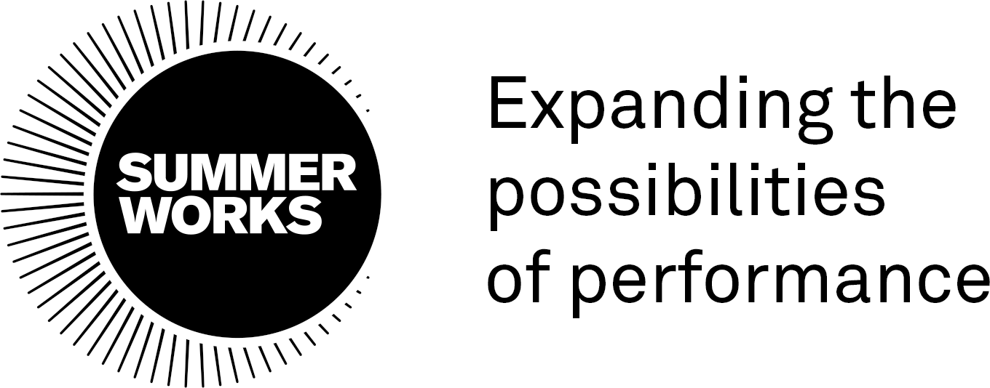

JOB POSTING: Marketing Manager - SummerWorks
____________________________________________________________

Title: Marketing Manager

Hours: May 6 - Aug 31, 2024
A mix of full- and part-time hours

Fee: $8,000 (+HST, as applicable)

Engagement conditions: Independent Contractor

SummerWorks expands the possibilities of performance. We are a leader, collaborator, and community builder at the forefront of contemporary performance – asking crucial questions; nurturing artistic innovation; and presenting new works that reflect the complexity and diversity of our society. Anchored by our annual SummerWorks Performance Festival in August, SummerWorks offers creation, presentation, and learning opportunities for artists and audiences. www.summerworks.ca.

The SummerWorks team works a combination of remote and in-person hours.

SummerWorks is committed to equity and diversity, both through our program of activities and as an employer. Our practices and procedures aim to reflect the varied needs, expectations and cultures of all members of our community. We make every effort to ensure that no member of the community receives less favorable treatment in our recruitment process or when accessing our services on the grounds of gender identity, disability, race, religion or belief, age or sexual orientation.

We warmly encourage applications from equity-deserving groups, including those who identify as Indigenous, Black, People of Colour, Transgender, Nonbinary, Queer, Disabled, Mad, and intersections of those identities.

SummerWorks will work proactively through all stages of recruitment to create a barrier-free hiring process and work environment, and will strive to provide accommodations when/where possible. For specific questions related to accessibility at SummerWorks, please visit https://summerworks.ca/accessibility/ or email info@summerworks.ca.

Marketing Manager: Description & Duties

The Marketing Manager is an essential role on the Festival team, supporting SummerWorks’ mission, vision, and values. The Marketing Manager is responsible for the communication of ongoing organizational activities and brand presence, and the promotion of programming and campaigns, including artistic programming, calls for submissions, fundraising, etc. related to the presentation of the 2024 SummerWorks Performance Festival (August 1-11). This role oversees the creation of all marketing collateral, as well as the delivery and distribution of these materials on a variety of platforms. The Marketing Manager works collaboratively with the SummerWorks team, artists, and partners to communicate with our audiences and reach a wider public with creativity, clarity, and authenticity.
Reports to: Artistic Director
_________________________________________________________

Marketing Manager: Responsibilities
Concept & Planning
- In collaboration with the SummerWorks team, develop and manage Festival marketing strategy, including plans for social media, print, web, radio, street, and transit, in consultation with the Artistic Director
- Liaise with publicists, web developers, graphic designers, printers, and distribution companies on behalf of the organization
- Liaise with artists to collect content, as well as write and edit copy, as required
- Provide input on brand and concept designs, as required
- Research and develop new opportunities for marketing and outreach, including media sponsorships and cross-promotional partnerships
- Manage the creation and scheduling of all advertising and social media campaigns
- Develop and manage in-house photocalls and video shoots for SummerWorks promotion and documentation, as well as Festival documentation
- Confirm Festival photographers, and create and maintain an overall Festival archival photography schedule.
Management & Delivery

- Lead the writing of all SummerWorks marketing and outreach materials, including, but not limited to: show descriptions for print, web, and socials; newsletter content; copy for advertisements and scripts for radio
- Develop and deploy social media content and advertisements across all SummerWorks social media channels (Facebook, Instagram, X (Twitter), Threads, LinkedIn, YouTube, TikTok)
- Oversee the compiling of the Festival program guide, tracking and relaying notes and changes to stakeholders, as required
- Manage the upkeep of the SummerWorks website, ensuring all content is up-to-date for the public, and necessary materials are accessible to the media
- Collaborate with SummerWorks’ staff and publicity teams, as well as partners, to ensure marketing and publicity messaging is consistent across all platforms
- Collaborate with the Accessibility Coordinator to ensure all marketing materials adhere to AODA guidelines and the organization’s accessibility protocols and considerations
- Collaborate with the Patron Services Manager to ensure all communications via Thundertix (Festival ticketing platform) are aligned with overall Festival messaging and brand guidelines
- Collaborate with the Festival publicist and Patron Services Manager to book media comps and reservations for all Festival activities and events
- Oversee the creation, design, and distribution of all marketing and outreach materials, including, but not limited to brochures, on-site signage, posters, billboards, and newsletters
- Manage the marketing departmental budget and timeline, including the reconciliation of the marketing budget, and provide regular reporting, as required
- Design and facilitate a marketing workshop, to be delivered via Zoom, imparting best practices to SummerWorks artists and the broader community
- Ensure that any marketing materials produced by artists or partners related to SummerWorks programming and activities follow brand guidelines
- Ensure that all marketing materials properly recognize sponsors, partners, donors and funders as required.

Archival & Reporting

- Oversee the organization and archiving of materials post-event (print, video, photos etc.)
- Create analytics reports for all media platforms
- Attend and contribute to the post-mortem process with the SummerWorks team and partners
- Oversee the reconciliation of the marketing budget and provide regular reporting, as required.

____________________________________________________________

Marketing Manager: Qualifications

It is essential that the Marketing Manager has:
- A minimum 3 years relevant experience in marketing and/or arts administration
- A passion for the performing arts
- Exceptional written and verbal communication skills
- A high level organizational and time management skills
- Attention to detail
- The ability to work independently as well as part of a team
- Social media proficiency across multiple platforms, including scheduling and management platforms (i.e. HootSuite) and analytics
- A strong, self-directed work ethic
- Experience with digital marketing and basic web editing (i.e. WordPress)
- Excellent computer skills, including experience of using Google Suite, Excel, Slack, Zoom, and project management software (e.g. Airtable) at an advanced level.

It is desirable that the Marketing Manager has:
- Knowledge of the goals and activities of SummerWorks
- Familiarity with the local, national, and international performance community
- Familiarity with online and print marketing platforms
- Previous experience planning and executing marketing campaigns for large-scale events or festivals
- Experience with basic graphic design and relevant software (i.e. Canva, Adobe Creative Suite).

__________________________________________________________

To Apply

To apply for the position, please email your resume to hiring@summerworks.ca by Monday April 15.

A cover letter is not required.

Please mention “Marketing Manager Position 2024” in the subject line and ensure that your full contact details are included in your resume.

Alternative formats for this posting:

For a downloadable screen reader version of this call, please click here:

Word Document in Black and White
PDF in Black and White

